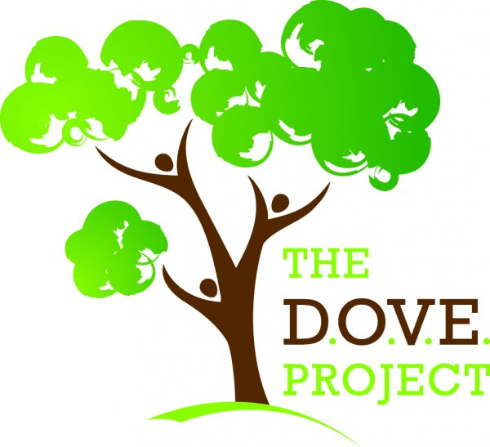
Job Description
Senior Support Worker

Department: Supported Living
Reports to: Coordinators, Deputy Manager, Registered Manager
Reporting Line: Support Workers

The DOVE Project’s Supported Living services provide home and community-based support for people with a range of needs, specialising in supporting young people and adults with learning disabilities. As a Senior Support Worker, you will take a lead role within a small team, providing mentorship and guidance to colleagues whilst assisting the service Coordinator and management team to ensure the highest standards of person-centred support are provided.

Purpose
- To support the Management team to deliver exceptional support services in line with The DOVE Project’s Policies & Procedures and best practise

- To support, motivate and provide guidance to Support staff, ensuring best practise principles are met.

- To contribute to auditing processes to ensure quality standards are met

- To act as a positive role model for the service user and the team ensuring consistency, trust and effective communication.

Key Responsibilities
- To report any safeguarding or Health and Safety concerns to the Coordinator/Deputy Manager and/or Registered Manager.
- To adhere to The DOVE Project Confidentiality Policy at all times.
- To lead with shadow shifts for new staff and provide mentoring support as required.
- To attend regular team meetings / support plan reviews and professionals’ meetings as and when required.
- To assist the Coordinator in ensuring the Care and Support plans and risk assessments are up-to-date.
- To assist the Coordinator with auditing processes to include Medication, Health and Safety and tenancy related checks.
- To liaise with the support team to complete SMART aims and outcomes relevant to the individual
- To ensure that all records and reports are completed as per company policy & procedures and report any issues to the Coordinator to action.
- To monitor Care Control entries and ensure consistent reporting and monitoring of finance records, ABC, incident & accidents and general notes.
- To record and action all correspondence as required, ensuring that information has been accurately communicated to your line manager
- To promote a healthy lifestyle and monitor that appropriate dietary plans are being followed by the staff team where appropriate
- To notify the Coordinator with regards to house repairs and ensure support staff are reporting issues as they are identified.
- To liaise with the court deputy to support the individual to manage their finances, report and record any finance discrepancies.
- To complete correspondence and follow up communication as advised by the Coordinator (i.e. Health Care appointments, payment of bills etc.)
- To support the individual with best value regarding utilities, phone & broadband, groceries, clothing etc and consult with the Coordinator with regards to purchasing large items
- To assist in setting up an activities/social calendar to evidence and monitor the support provided in consultation with the Coordinator
- To attend regular senior support worker meetings / training as required
- Revise and update the PBS plan (Positive behaviour support plan)

This role is in addition to that of the Support Worker job description

NB - This job description is not exhaustive and there may be times you will be required to undertake other duties in order to meet the needs of the people we support.

Person Specification
Senior Support Worker

Experience - Essential
- Supporting adults with a Learning Disability and behaviours that challenge

Experience – Desirable
- Experience of leading a staff team
- Delivering personalised services in a supported living setting
- Involvement in support and care planning processes

Knowledge
- A good understanding of learning disability/mental illness and its impact on clients
- Understanding of key CQC regulatory requirements
- Understanding of safeguarding procedures and protocol
- Knowledge and understanding of the Fundamental Standards
- An understanding of the key principles of Active Support and Person-Centred Planning

Qualifications
- PREFERABLE: NVQ Level 2 in Health and Social Care or QCF qualification equivalent
- To have, or be willing to work towards additional qualifications in Health and Social Care
- Hold any other relevant qualification

Skills and Abilities
- Ability to lead, motivate, and be a role model to the staff team
- Ability to build and maintain effective relationships and communication with the person supported, their family and other professionals
- Ability to create and complete reports in a clear, concise and professional manner
- Ability to work effectively as part of a team
- A flexible and pro-active approach to working hours
- Excellent communication skills

