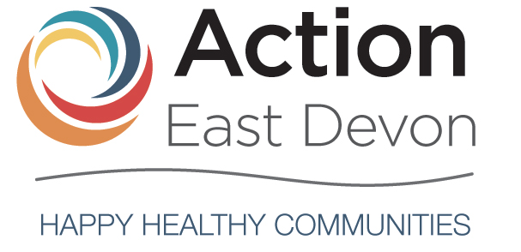

Who we are
Action East Devon is a small-medium sized charity and registered company delivering services across East Devon. We currently support:
- Young people’s mental health and wellbeing through our Headlight project
- Older people’s wellbeing using reminiscence and music through our Forget Me Not and Musical Memories project
With East Devon District Council we have looked at local needs, especially as the area emerges from the pandemic. We are developing our new strategy to focus on wellbeing for all ages, to align with the Council’s Health and Anti-Poverty strategies, and to work in partnership with other local organisations.
What will you be doing?
With our new CEO, a small but skilled Board of Trustees, active engagement with East Devon District Council and other charities in our area of operation, we must respond to the increasing demands on us.
We have adopted an ambitious fundraising strategy to identify sources of support to enable us to meet demands from our community.
We are seeking one or two Trustees to help us build back after the pandemic and to grow.
What are we looking for?
Our one or two new Trustees should have:
- A commitment to our mission and strategic vision
- Independent judgement but an ability to work effectively as a team member
- A willingness to meet the minimum time requirement of quarterly Board meetings and an annual strategy meeting
We are keen to hear from potential Trustees with organisational growth/fundraising and bid-writing experience, and from someone with a background in HR.
You may already have experience in charities, public service or working at Board level in other areas. We will invite any prospective Trustee to observe one of our Board meetings and, if appointed, provide induction to work.
Our governance is strong. The role of the Board of Trustees is to hold the charity ‘in trust’ for current and future beneficiaries by:
- Ensuring the charity has a clear vision, purpose and strategic direction and is focused on achieving these
- Being responsible for the performance of the charity, ensuring the charity complies with all legal and regulatory requirements
- Acting as guardians of the charity's assets, both tangible and intangible

As well as the statutory duties, any Trustee should make full use of their specific skills, knowledge or experience to help the Board make good decisions.

We are a limited liability organisation which caps liability of members to £10 and as we maintain indemnity insurance for the benefit of our trustees.

What difference will you make?
You will be:
- Engaging with a wide range of stakeholders and working with a dedicated Board of Trustees, staff and a number of committed volunteers to make a significant difference to the lives of people, principally in East Devon but with an expanding wider reach across Devon
- Helping Action East Devon grow to meet demands from the community and to be strategically well positioned and well-funded for the future
What's in it for the volunteer?
As a relatively small charity we are open and welcoming. Our aim is to make incoming Trustees enjoy their role and to gain personal satisfaction from their participation.
If you are interested in joining us, the Chair of the Board of Trustees, Graham Fice, would be glad to have an informal discussion. Please email info@actioneastdevon.org.uk. If you would like to apply for the role, please send your CV with a covering email to info@actioneastdevon.gov.uk and we will contact you to arrange a meeting.
(Please note that as part of our forward planning our website actioneastdevon.org.uk is currently under major redevelopment but we will be glad to give you any further information you may want).

